**Under VPC network select firewall rules**:

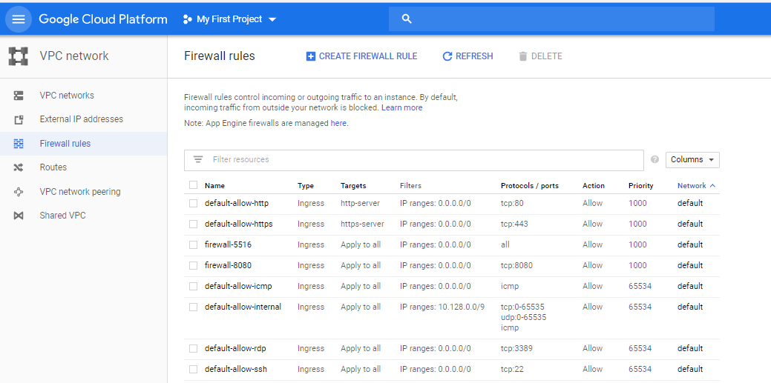

**Ex: Firewall setting for port 8080:**

